**Human Detector and Counter: Enhancing Security with Python-Based Surveillance**

1. **Introduction**

* **Background**

In recent years, the integration of computer vision technologies into security systems has become increasingly prevalent. Object detection, particularly human detection, plays a crucial role in enhancing surveillance capabilities. This technology enables real-time monitoring and automated alert systems that can significantly improve security measures in various environments such as public spaces, private properties, and sensitive areas.

* **Objective**

The primary objective of this project is to develop a Python-based human detection and counting system using the YOLOv3 (You Only Look Once version 3) object detection algorithm. This system aims to provide real-time detection and counting of human figures in video feeds, thereby enhancing security through automated monitoring.

1. **System Design and Architecture**

* **Overview**

YOLOv3 is a popular object detection algorithm that is renowned for its speed and accuracy. Unlike traditional methods that perform object detection in a multi-stage process, YOLOv3 divides the image into a grid and predicts bounding boxes and class probabilities simultaneously. This enables YOLOv3 to achieve real-time performance, making it suitable for surveillance applications.

* **Components**

**HumanDetector Class**

* **Initialization**: The ‘HumanDetector’ class initializes the YOLOv3 model using pre-trained weights and configuration files. It also loads class labels from a names file.

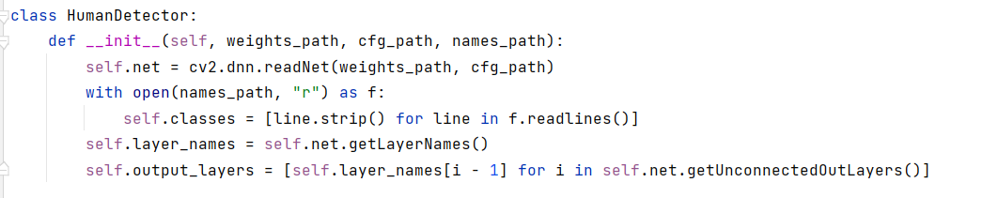

* **Detection**: The ‘detect_and_count_humans’ method processes frames from the video feed, detects humans, and counts their occurrences.

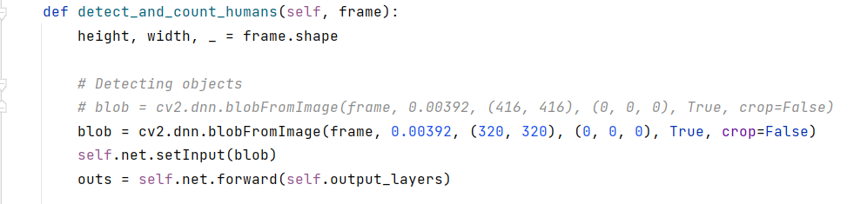

**Main Function**

* **Setup**: The main function initializes the HumanDetector, sets up video capture, and processes each frame to detect and count humans.

It includes file existence checks, initialization of video capture, and real-time processing and display of frames.

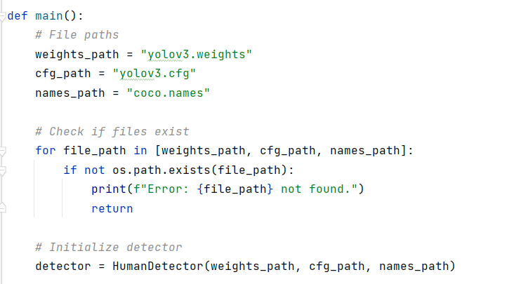

1. **Implementation Details**

* **Dependencies**

The system requires the following Python libraries:

* **OpenCV** (opencv-python): For image processing and object detection.
* **NumPy** (numpy): For numerical operations and data manipulation.
* **Code Explanation**

1. **Initialization**

* **YOLOv3 Weights and Configuration**: The model is loaded using pre-trained weights and configuration files, which define the network architecture and training parameters.
* **Class Labels**: Class names (e.g., "person", "car") are loaded from a text file, which provides the labels for detected objects.

1. **Detection Process**

* **Blob Creation**: Converts the input image to a blob, which is a normalized format suitable for input into the YOLOv3 network.
* **Forward Pass**: The blob is fed through the network to obtain detection outputs.
* **Parsing Outputs**: Extracts bounding boxes, confidence scores, and class IDs from the network’s outputs.
* **Non-Maximum Suppression (NMS)**: Filters overlapping bounding boxes to reduce duplicates.
* **Drawing Bounding Boxes**: Annotates detected humans on the frame with bounding boxes and labels.

1. **File Handling**

* **File Existence Checks**: Ensures that the required files (weights, cfg, names) are present before proceeding with initialization.

1. **Running the System**

* **Setup in PyCharm**

1. **Create a Project**: Open PyCharm and create a new Python project.
2. **Install Libraries**: Navigate to File > Settings > Project: YourProjectName > Python Interpreter and install opencv-python and numpy.
3. **Add Code**: Copy the provided Python script into a new file (e.g., human_detector.py).
4. **Download Files**: Ensure YOLOv3 weights, cfg, and coco.names files are in the project directory.

* **Execution**
* **Running the Script**: Execute the script using the "Run" button in PyCharm or by right-clicking the file and selecting "Run 'human_detector'".

1. **Adjustments**: Modify file paths if the weights, cfg, or names files are located elsewhere. Ensure the webcam or video file path is correctly specified.
2. **Results**

* **Performance**
* **Real-Time Detection**: The system performs well with real-time processing, maintaining an adequate frame rate for live video feeds.
* **Accuracy**: YOLOv3 provides accurate human detection with minimal false positives. The confidence threshold (0.5) and NMS threshold (0.4) help in filtering out non-human objects.
* **Challenges**
* **False Positives/Negatives**: Handling variations in lighting, occlusions, and different poses can affect detection accuracy.
* **Computational Load**: Real-time processing requires a capable GPU for optimal performance. Performance may vary depending on the hardware used.
* **Applications**
* **Security**: Can be deployed in security systems for monitoring access to restricted areas.
* **Public Safety**: Useful in crowded areas for counting people and managing crowd sizes.
* **Smart Homes**: Enhances home security systems by detecting intruders.

1. **Output Images**

* **Live Webcam Feed**

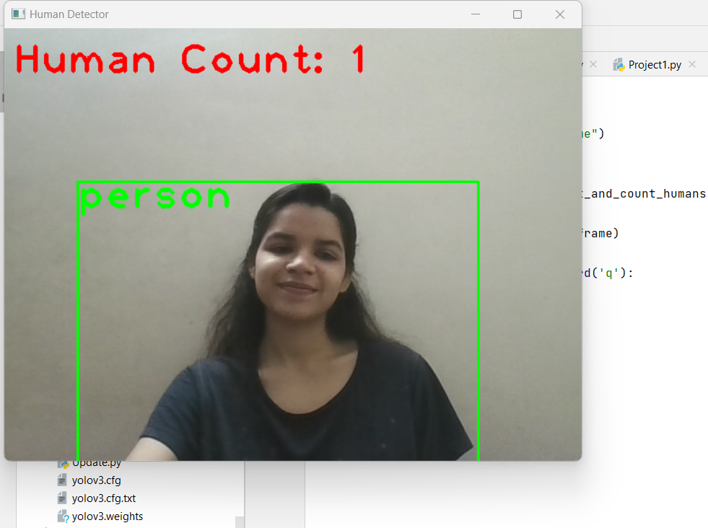

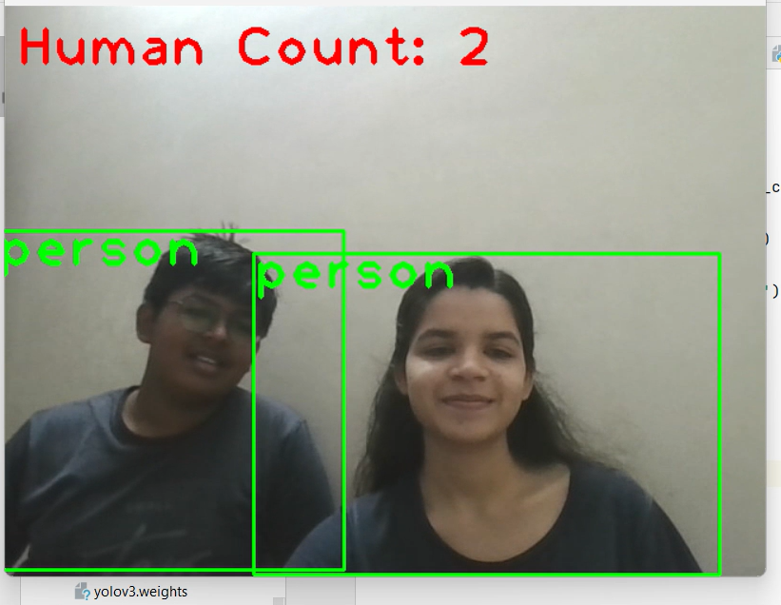

This image shows the live feed from the webcam with detected humans highlighted by bounding boxes and a count displayed on the screen.